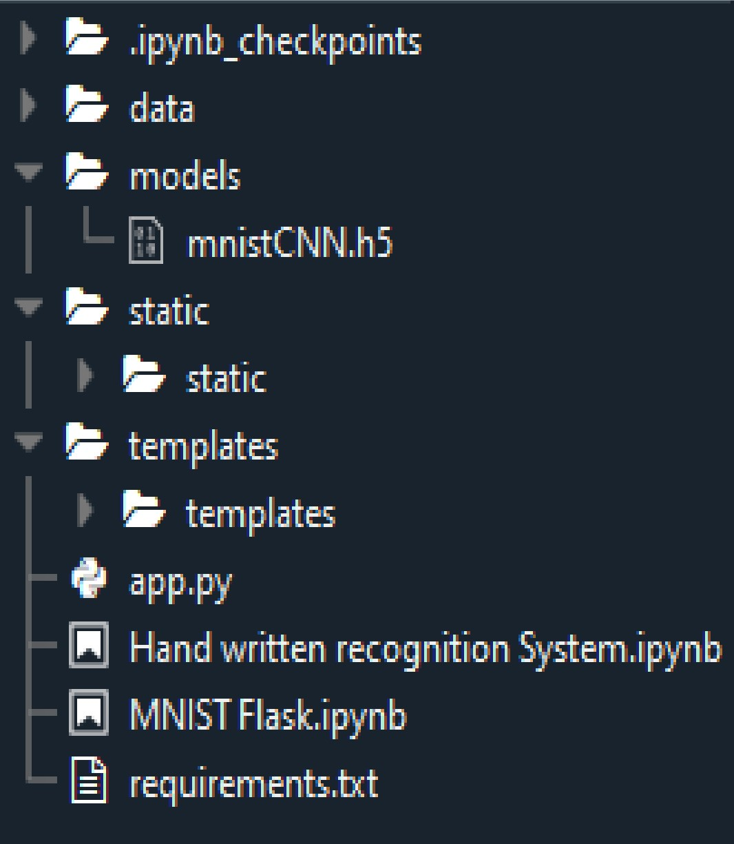

**TEAM ID:** PNT2022TMID32478

**PROJECT NAME**: A novel method for handwritten digit recognition system